Move Block – Tutorial 1

# Question 1

## Moving Straight

1. Move forward 5 rotations in a straight line. Use the Tank block..

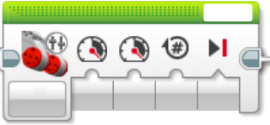

Figure - Move Tank Block.

# Question 2

## Turning

1. Turn left in one spot as shown in Figure 2.

*Hint – What happens if the power on the left and right motors are different?*

Figure - 90 Degree turn left.

# Question 3

Can you match the movement shown below?

Figure - Challenge problem map.

# Challenge Problem

Can you use the touch sensors to perform to different movements on commend?

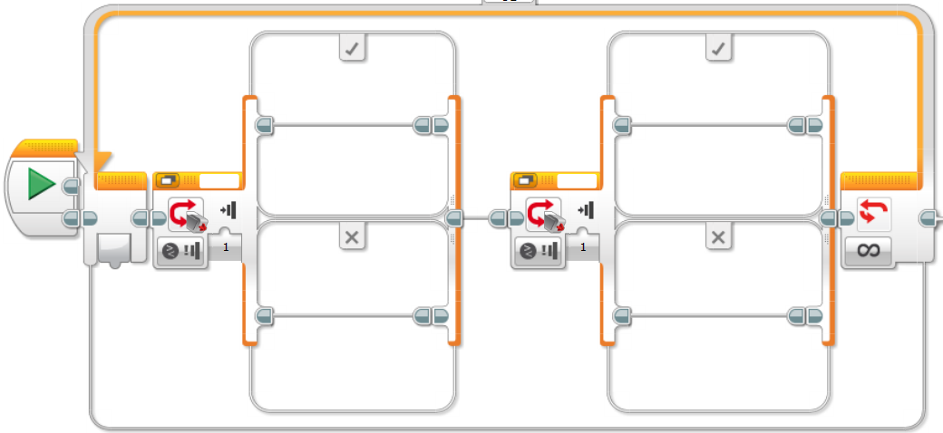

Perform your 2nd movement here

Perform your 1st movement here

Do Nothing

Do Nothing

Select Sensor 2

Select Sensor 1